# **Software Projects Milestone 4**

# **Prototyping Completed**

## **Group Number: 20**

## **Concept Name: Garden Assistant Application**

## **Activity Planning**

When we first started M4, we decided to plan out the entirety of our goals from that date up to the final submission date for M4, a full month later. Initially, Khari McGhie used Google Docs to create a file as our planning tool as we could simultaneously edit and view the file.

This file was separated into different time-gaps where we planned for milestones to be met within and by specific dates. This was done so that we’d always be aware of whether we were on track so that we wouldn’t run out of time. As well as the file being separated, each milestone was accompanied by the names of who would actually carry out/complete the task.

However, the plan created on Google Docs was only planned to be temporary as we knew that we needed someone more efficient. Therefore, as time went on, a Gantt Chart was made by Habib in addition to the Google Docs file.

Post completion of the design phase of our software, all tasks leading up to the prototyping and testing phase have been completed. As such, a general overview of our planning is reflected in the Gantt chart posted below. Division of tasks are chronologically arranged with activity planning taking precedence before all subtasks under prototyping. Through prioritising planning of the M4 submission from early on we were able to seamlessly complete the necessary tasks. Since, all predecessors to the M4 were clearly illustrated, and all members were distinctly aware of their assigned roles leading up to achievement of this milestone.

## **Low-Fidelity Prototyping**

You should present evidence that you constructed low-fidelity prototypes that show the essence of your concept so that stakeholders can give you feedback. The feedback that you should be seeking is how close the concept, as you have represented it in your prototypes, resembles what your users understood that you would be producing and if it is what they want. This section should also describe the stakeholder consultation that took place using the low-fidelity prototypes and how the feedback was used by the team to improve the concept.

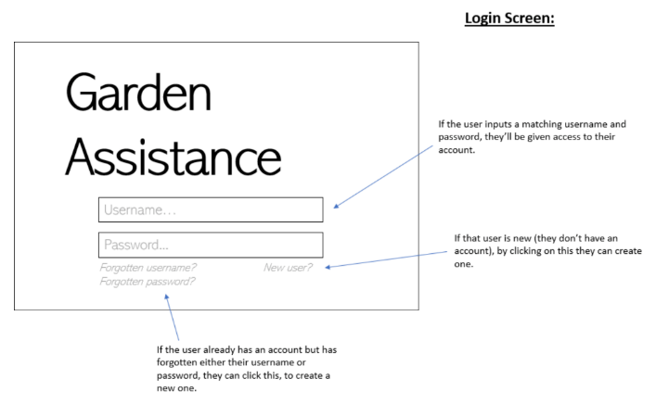**Our low-fidelity prototypes are presented in the following screenshots:**

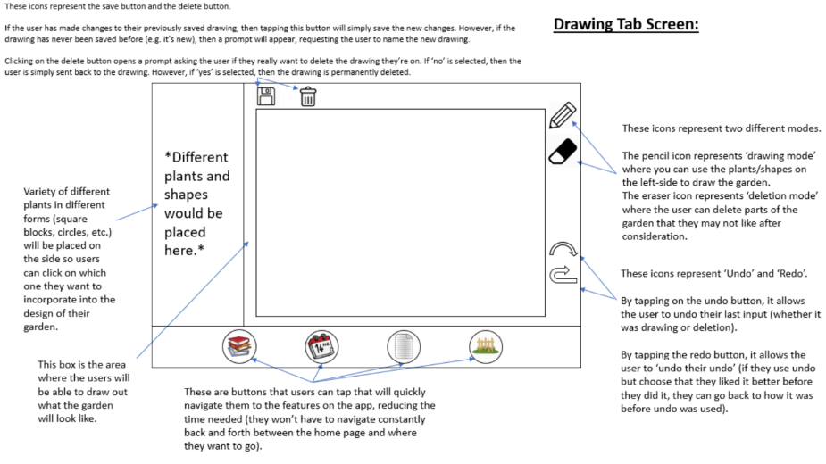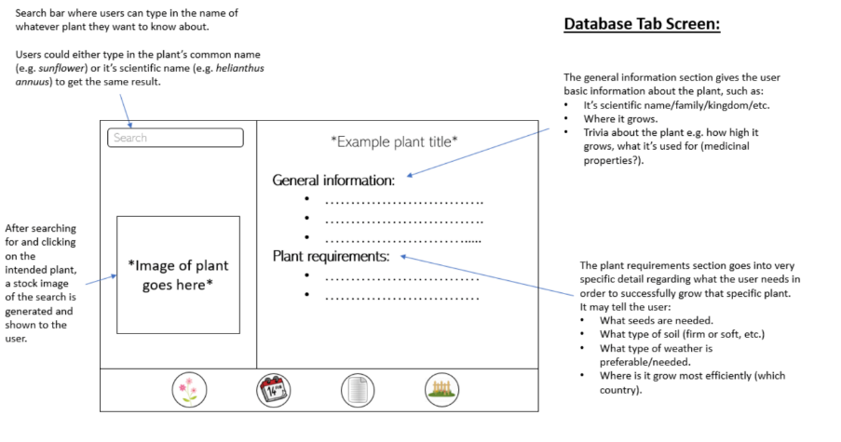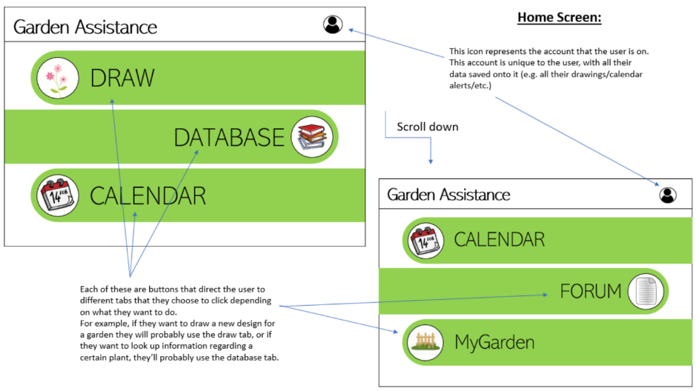

## 

## 

### **Evaluation of low-fidelity prototypes – Completed by Arianna Sankar:**

At the start of this project, I interviewed potential stakeholders (people with a gardening interest) who would find our app useful. We have since refined our concept, created models and produced low-fidelity prototypes.

I then showed the stakeholders the low-fidelity prototypes in order to gain a better understanding of what they had in mind and their feedback on what improvements could be made in order for this app to fully assist their needs.

As a group we decided that the prototypes should be displayed to the user on a tablet. The reason for this is because the size of a tablet is more suitable to use in the garden as a mobile phone would be too small and difficult to navigate, especially if their hands are muddy.

The stakeholders therefore reviewed our prototypes on the tablet and were asked to give their thoughts/feedback on the following areas:

1. Home screen
2. Drawing feature
3. Database of plants
4. Calendar feature
5. Forum feature

I evaluate their responses as follows:

**Home screen:**

The stakeholders felt the layout of the menu was extremely clear and easy to navigate as the icons were large making it easy for them to activate, especially with muddy hands in the garden.

They felt one improvement could be to include a weather update at the top of the screen which would alert them to any weather warnings.

**Drawing feature:**

The stakeholders liked the drawing feature and thought that the layout was clear and easy to use. From first glance, the icons such as: save, delete, pencil, eraser, undo and redo were easy for them to understand. They also liked the list of various plants and shapes, however they said that when using the canvas, you should be able to close this tab so they can access the full canvas.

I explained to the stakeholders how the drawing feature would work:

* You would specify the measurements of your garden and use the drawing tools to define the layout.
* You would drag and drop the plant selected onto the canvas.
* Before positioning the selected plant on the canvas, the system will alert you as to whether this is a suitable position (i.e. optimal sunlight, soil type). Once the plant has been positioned, the requirements for that plant will be transferred to the calendar.
* You would be able to edit your garden at any time.

The stakeholders liked that they were able to do the following:

* Fully design their garden by specifying measurements, creating a floor plan and notifying the system of typical shady and sunny areas of the garden.
* Choose from a selection of plants and place them on the canvas.
* Receive notifications of any plant requirements from the plant selected.

However, the stakeholders expected better functionality of the drawing feature. They felt the drawing feature should give an enhanced visualisation of their garden so they could see what the plants would look like once positioned. At the moment their drawings are flat (2D) and even though the system would be providing useful tips on how to grow their plants, they were still disappointed on how the drawing feature worked.

When asked how this could be improved and what they would like to see in the app, they commented as follows:

* Improvement to visualisation of their garden. They would not have the time or patience to specify the measurements or layout of their garden. They would prefer to take a picture or hold up their camera on the tablet and be able to drag and drop their chosen plants onto the canvas to get a better idea of what the plant would look like.
* When they hover over the plant, a summary of the plant’s requirements i.e. whether this is a suitable position should appear.
* They could not think of any reasons why the pencil and eraser features would be helpful.

**Database of plants:**

The stakeholders felt this would be extremely useful to them, in particular the general information, image and plant requirements. One of the stakeholders said that they have very little knowledge about plants and that this database would be invaluable to them instead of having to search through the internet being redirected to different websites which they find confusing.

They also questioned whether this had to be a separate feature. One stakeholder commented that there is already a list of plants on the drawing feature and felt that the information could be combined so that it is only displayed in the drawing feature.

**Calendar feature:**

This feature was received positively by the stakeholders and they commented it was exactly how they envisaged it. They thought that the interface was clear and user-friendly. They also felt that the automatic reminders (sent from the selected plants in the drawing feature) and being able to manually add a reminder was invaluable.

One feedback was that if the weather forecast on a particular day was rain, the system would alert them so that they do not waste time or water resources watering the plants.

Forum feature:

This feature received mixed reviews.

Some of the stakeholders said they would not find this feature of use to them and would probably not use it, however if designed with elderly people in mind they would be willing to give it a go.

However, the other stakeholder said they would find this useful as they are an inexperienced gardener and felt an online community platform would be invaluable. They were confident that the app is already providing helpful information but having this option would expand their resources.

**Conclusion:**

In conclusion, the stakeholders were pleased with the progress of this app and that these prototypes illustrated something they had in mind. They were satisfied with most of the features and felt that they would fully assist them with their gardening.

They were disappointed with the outcome of the drawing feature and would only be willing to use this feature if the suggested changes were made because at the moment they do no find it useful.

When asked if any other features should be included, they felt that the current features covered all of their needs.

Overall, the stakeholders feel confident that this app could help make a difference, not only to their gardens but by also creating greater awareness on how to look after your garden. One of the stakeholders explained that they recently read an article which highlighted the significant increase of plant extinction through a lack of care and maintenance. This stakeholder raised a valuable point, if the app is user-friendly and has a modern appeal such as including a visual drawing feature, then the demographic for this app could grow considerably as more people would become more confident with gardening and as a result will learn about the importance of caring about our ecosystem which in turn could make a positive impact on our environment.

## **High-Fidelity Functional Prototype**

You should present evidence that you constructed high-fidelity functional prototypes using a tool such as powerpoint or a simple HTML/CSS/JS site that show how your concept could be used and how it would be behaving so that stakeholders can give you feedback. The feedback that you should be seeking is how useful and useable the concept as you have represented in your prototypes is and if it is what the stakeholders want. This section should also describe the stakeholder consultation that took place using the high-fidelity prototypes and how the feedback was used by the team to improve the concept.

**Implementation of Hi-Fidelity Function Prototype:**

**Tools used:** p5.js, jQuery, CSS, html language, JS Libraries from Axure

**Live version of hi-fi Prototype:** <http://softproj20.pages.doc.gold.ac.uk/Gardening-Webapp/>  
*(as of 21 Nov 2019, it might be taken down in few weeks)*

**Screenshots:**

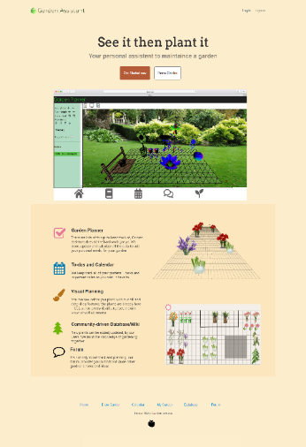

Figure 1 Pilot page

*Figure 1 page takes user’s feedback into account, with a more user-friendly approach to introduce our product.*

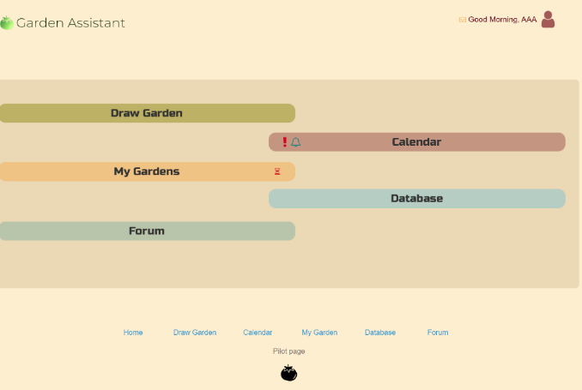

Figure 2 user panel

*Figure 2 page’s layout has been reworked, fits all menu items onto one screen.*

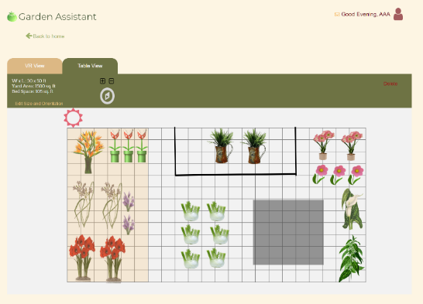

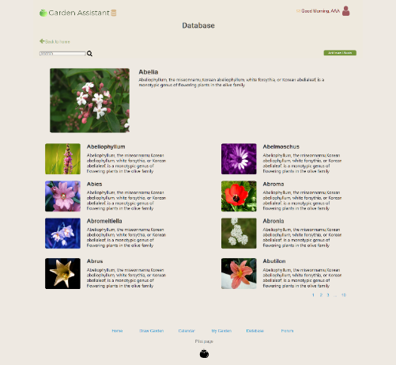

Figure 6 Database

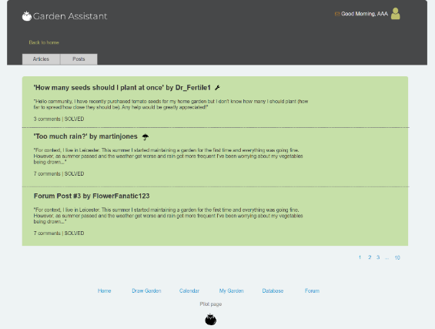

Figure 5 Forum

Figure 4 Table view

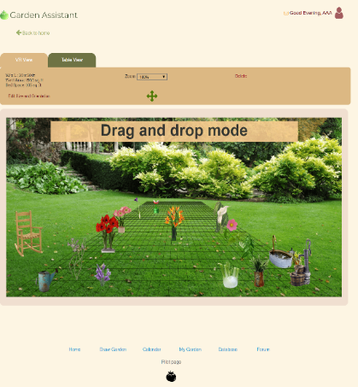

Figure 3 my garden page

### **Evaluation of high-fidelity functional prototypes – Completed by Arianna Sankar:**

At the start of this project, I interviewed potential stakeholders who would find our app useful. We have since refined our concept, created models and produced low-fidelity prototypes. After demonstrating low-fidelity prototypes to the stakeholders and gaining insightful feedback, our group were able to reflect on their responses and use this invaluable information to complete the high-fidelity prototypes.

The stakeholders therefore reviewed our prototypes on a tablet and were asked to give their thoughts/feedback on the following areas:

1. Home screen
2. Drawing feature
3. Database of plants
4. Calendar feature
5. Forum feature

I evaluate their responses as follows:

**Home screen:**

The stakeholders liked the design of the web app, in particular the use of vibrant colours and a clear user-friendly layout. They also liked the index page and described it as “professional”, in particular the use of the summaries for each feature were clear.

However, the stakeholders did comment on numerous grammatical errors which would be detrimental as it detracted professionalism.

**Drawing feature:**

The stakeholders really liked the drawing feature and felt that their feedback from the low-fidelity prototypes were taken into account. They liked the option of having the grid and being able to simply ‘drag and drop’ their chosen plants, but were more excited about having the augmented reality feature which gave them an enhanced visualisation of their garden. They said that compared to the previous low-fidelity prototype, this feature is easier for them to use and would be of great benefit to them.

One improvement would be that when they select the plant, the requirements should appear i.e. suitable position for optimal sunlight.

**Database of plants:**

The stakeholders very much liked this feature, in particular the clear layout, use of imagery and the search bar to help refine their results saving an enormous amount of time scrolling through internet results. Another stakeholder said that it was nice to have all of the plant information in one place.

**Calendar feature:**

This feature was once again received positively by the stakeholders and they commented it was exactly how they envisaged it. They felt the interface was clear and user-friendly.

A feedback from the low-fidelity prototype stage was that “if the weather forecast on a particular day was rain, the system would alert them so that they do not waste time or water resources watering the plants.” They were disappointed that this had not been included. They also wanted to see an example of how reminders would work. I therefore explained to them how this would work and confirmed it would be included in our final web app, they then felt more confident with this.

**Forum feature:**

Previously, this feature received mixed reviews but the stakeholders then decided that this would be of enormous help to them. They agreed that the layout was user-friendly and was designed for elderly people in mind.

**Conclusion:**

In conclusion, the stakeholders are happy with the progress of this app and feel confident that their gardening needs will be met. They still stand by their previous comment that this app could help make a difference and spread awareness on how to look after your garden.

They were highly satisfied with the consistent design and clear layout of the web app and were confident that they would be able to use it with ease due to the user-friendly navigation. One of the stakeholders commented that now the design feature has been enhanced and the overall design creates a modern appeal, they feel that the demographic for this app has risen.

They now really like the drawing feature and were pleased that their advice was taken into account.

Areas for improvement:

* Vital that text is clear, concise and free of grammatical errors.
* The design feature should enable a notification so that when the stakeholder selects their chosen plant, the requirements should appear i.e. suitable position for optimal sunlight.
* The calendar should include weather warnings.

## **High-Fidelity Technical Prototype**

You should present evidence that you constructed high-fidelity technical prototypes that you as a team used to test a technology (eg a database, web vs mobile app etc) that might be suitable for your project. This section should also describe how the fprototype was used by the team to improve the concept.

When creating the high-fidelity technical prototypes, we were each assigned a feature to work on.

**User Authentication, *Google Firebase*** (*Completed by**Arianna*)

Arianna was in charge of completing the technical prototype for the login system. I used HTML and CSS to create and style the login system. In order to test the technology that will be required for this login system (a database), I used JavaScript to provide functionality and Firebase. Firebase allowed me to mirror how the login system will work. I created a Firebase project and manually created a user, this required an email address and password. In the JavaScript file I imported the SDKs for Firebase in order to establish a connection and an authentication library. I then retrieved the email address and password entered (in the HTML login form) using DOM manipulation and used a Firebase authentication function which used these values and passed them as arguments in order to check whether this account exists in the Firebase database. As a result of this prototype I was able to successfully research and use Firebase as a cloud database and create a working login system which was connected to this database to check whether the account entered existed. I also implemented validation checks so that if the credentials are incorrect, the user is prompted to login again.

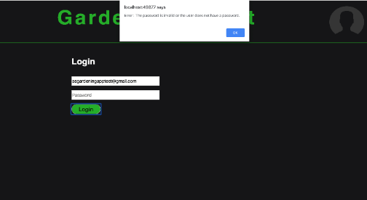

Figure 8 If the user leaves the password field blank, an error message is displayed.

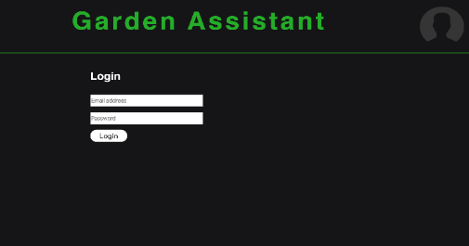

Figure 7 This is the login form.

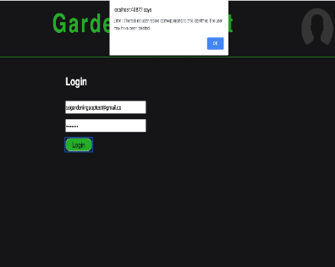

Figure 9 If the user enters incorrect login details, an error   
 message is displayed.

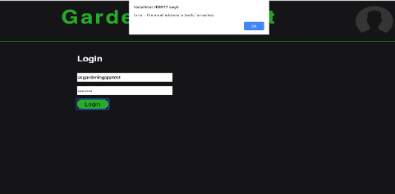

Figure 10 If the user enters a badly formatted email address,   
an error message is displayed.

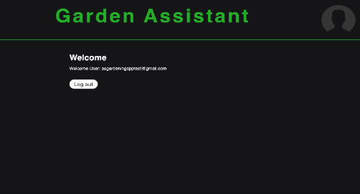

Figure 11 Once the user successfully logs in, they are directed to their account page.

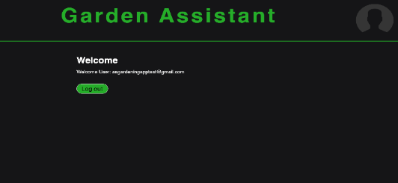

Figure 12 When the user’s cursor hovers over the log out button (implying they wish to log out of their account) the colour of the button changes.

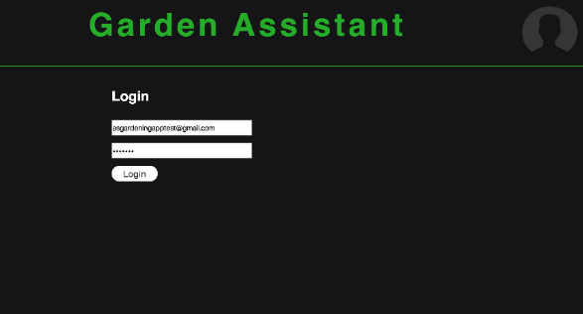

Figure 13 When the user presses the log out button, they are redirected to the login page.

**Calendar application, node,js and express** (*Completed by**Taylor*)

To prototype this application, I created an sql database and table inside my virtual server. I also created a test bed web application on the virtual server using express I then connecting to the database using node.js. in attempting to implement this I came across a major problem where I was unable to easily pass a variable from a server-side java script file to a client-side java script file. This made it almost imposable to use my database query from the index.js (server side) file to populate the calendar using the demo.js (client side) file. I was however able to render the results in the index.ejs file (client side). from my experience creating this prototype it is clear that I will have to research a piece of software that can handle passing data more easily from the server to the client.

this image shows how I have structured the testbed web app. It has the index.js file in the root, a routes folder that holds the main.js file that acts as middleware, a views folder that holds all html and ejs files and a public folder to hold all static css and js files.

## this image is of the index.js file it handles all of the server-side functions at the top is the database connection followed by a connection test.

This image is of the main.js file this file acts as middleware for the web app. In this you can see that when the URL has only “/” after it, an sql query will be implemented then if the query is successful the index.ejs file will be rendered passing in the results of the of the sql query.

This is an image of the index.ejs file that calls the calendar.js application and the demo.js file that gives calendar.js file parameters to run.

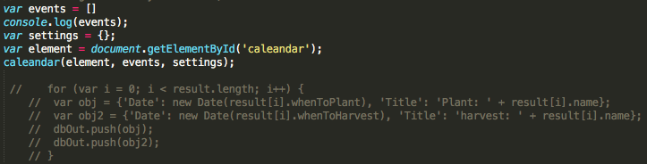

This image is of demo.js. the events variable holds an array of objects that populate the calendar. You can see there is commented out code that would fill the events variable if the results of the database query could have been passed to the file.

This image shows the application running using node. With a console log of the results from the database query.

this is the calendar application working through a browser as you can see the results from the database are being printed as a html element with the calendar functioning below.

**Drawing Feature, *Augmented reality and grid*** (*Completed by**Huan*)

There are 2 ways to implement the idea of drawing, real AR and AR-alike, we will work on the AR-alike while finding a way to do real AR at the same time.

1. **AR-alike**

To achieve this, one of the methods is to use a JavaScript library called Three.js, together with jQuery. *getUserMedia()* method will be called first to determine the front/rear camera to be used, then draw a perspective grid on floor, before drag 3D plant models onto canvas, user will need to align the grid with garden’s floor.

Following are screenshots taken when testing:

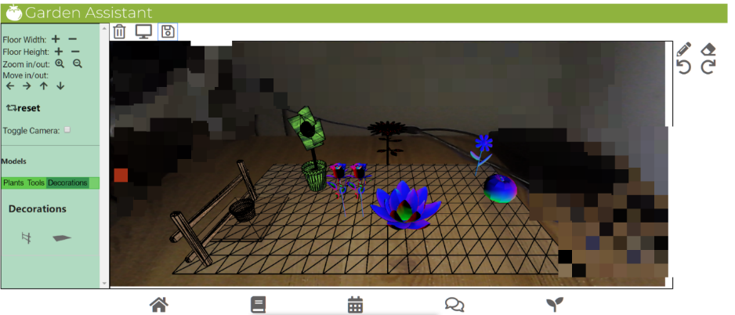

Figure 15 AR-alike with objects

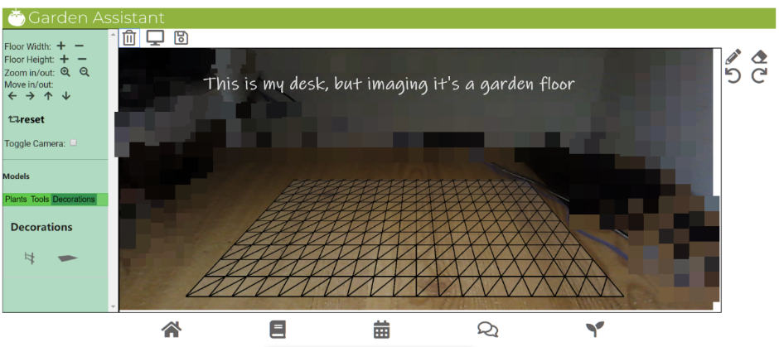

Figure 14 AR Test without any object

A closer look:

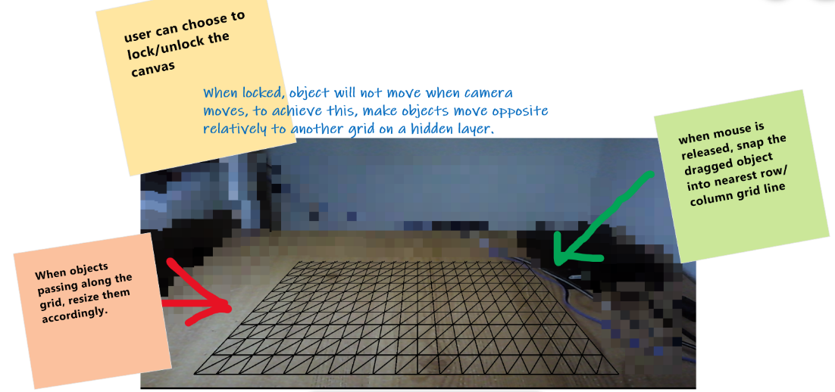

Figure 16 AR-alike: a closer look

1. **Real AR**

I need more time to think on this. After some searching on the web, there are three types of AR: Marker based, Marker-less, Location based.

The first one is not useful for our project, since it needs a marker/pattern picture placed, and user will use their phone to scan it. The last one is more like a city-scale AR, for example, this one: <https://scape.io/> .

**Marker-less AR will be the best path to go for**, I have found some resources for this, and picked some, those are the libraries that most likely will be using:

* **Babylonjs**
* **argonjs**

The libraries must work with WebGL, since our app targets on browsers. ‘AR on the web’ is still a brand-new area within IT industry, unlike mobile AR apps, they work because the hardware supports those functionalities.

There is a mobile app out there does the similar thing as we do: <http://www.plantlifebalance.com.au/the-app/>

I will try to reach them, or dig further to find out how they achieved the functionality we are looking for.

## **Open Questions about this concept**

Having completed the steps of modelling your concept in prototypes, make a list of existing or new open questions that you will need to answer about functionality or design before you can start to develop your product. These are the questions that you will attempt to answer before you can finally specify your concept prior to building it.

### **How our UML Diagrams changed:**

**Upon completion of our low-fidelity prototypes, these were shown to the stakeholders. As a result we received many positive reviews however the main area that needed improvement was the drawing feature. We then amended this feature hence our UML diagrams have changed and these are highlighted below.**

## **Use Cases:**

In order to understand how use cases work, we used the following resource from the library: Using UML software engineering with objects and components by Stevens, P. & Pooley. (The citation can be found in the bibliography). This book explains that use cases portray “the behaviour of the system” from the user’s perspective. A user can represent a person or “information system”. The purpose of use case diagrams enables us to refine the requirements of our system as well as plan our development. We have redesigned the use case diagrams to follow the principles set out in the book. As we will have 12 weeks to implement this system, we have decided to focus on building this system for normal user stakeholders i.e. hobbyists, aspiring enthusiasts. However ideally our drawing app will also cater for professional stakeholders and back-end users as previously mentioned in Milestone 3.

Wiki database API

**System**

System Authentication

<<extend>>

<<extend>>

Registered user

New user

As our main area of improvement was the drawing feature, the sequence list, sequence diagram and activity diagram have slightly changed. The concept of the calendar and database have not changed as the stakeholders were satisfied with these features.

**Sequence List**

* Open the app
* Enter their login details
* A menu of all of the features are displayed
  + Plan and draw the garden
  + View personalised calendar
    - Review event
    - Add event
    - Receive alert
  + Viewing database of plants

**Scenario 2 – using the drawing features:**

1. The menu is displayed on the screen and the user presses the ‘DRAWING’ feature to create/view/edit their garden plan.
2. This feature uses augmented reality enabling the user to use their device’s camera which will then scan their garden and this live image will form part of their canvas. They also have the option to view grid lines for better accuracy on where to place their plants.
3. They can then select the 3D plant models they would like in their garden using ‘drag and drop’. Augmented reality will allow a more visual representation of what the plant will look in their garden.
4. As they select a plant, important information will be displayed about the best position for optimal sunlight etc.
5. If they confirm this plant, the important information will be transferred to their personalised calendar to remind them of upcoming events to maintain the plant.

## **End-user Sequence Diagram:**

From studying this book, we now understand the purpose of UML, in particular it provides interaction diagrams such as a sequence diagram. A sequence diagram is described as being “expressive” in order to illustrate different actions depending on user input and continuous iteration of particular behaviour.

Our sequence diagram has been amended (following the definition set out in the book) in order to portray how our design feature has changed. Now that our feature will use augmented reality, the requirements from user input has changed. For example, the below diagram now shows that the user must use their device’s camera and hold up their camera as if they were taking a photo of their garden. Augmented reality will enable their garden to be used as a live image and this will form part of their canvas. They can then drag and drop 3D models of the plants and place it in their garden. Depending on where the plant is placed, the system will check whether the position is appropriate in terms of optimal sunlight.

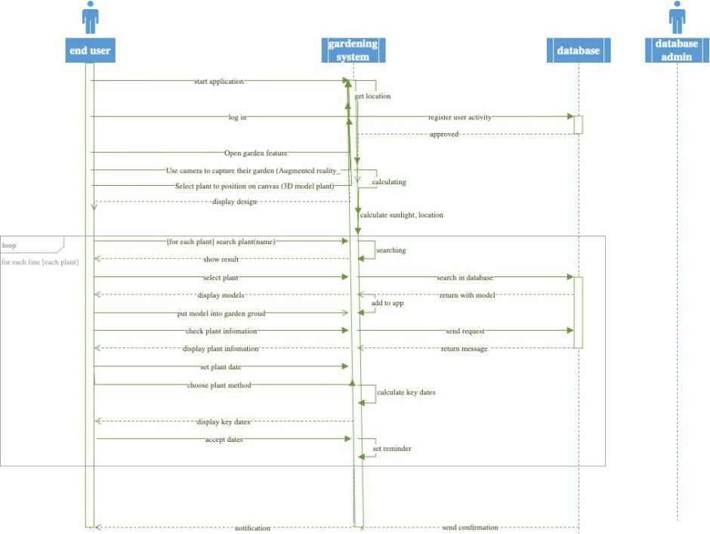

### **Activity Diagram:**

The activity diagram has also changed in order to illustrate how our drawing feature will now work.

